Art Catalogue: Prints & Paintings

1. Moon
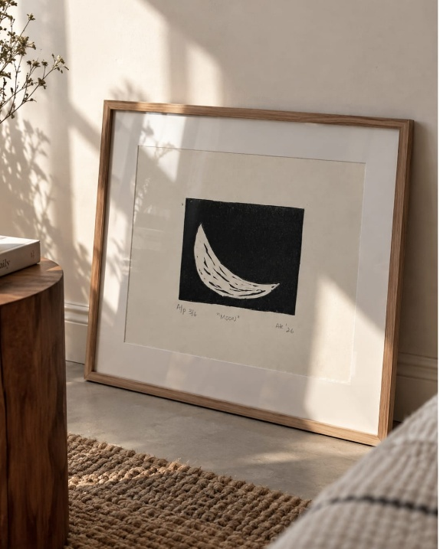
- Title: Moon
- Theme: Shiva element
- Year: 2026
- Frame dimensions: 20 × 17 cm
- Print dimensions: 8.2 × 6.7 cm

Writeup
Moon is a small linocut print that began as a rough idea carved into a block. It is the first piece in a series made for Shiva, and the moon was chosen as the softest way in. Small in scale, it carries the whole series.

Instagram Captions
- This little moon started as a rough idea on a block, and now it's sitting in a frame like it's always been there. So small, yet it carries the whole series.
- I've been wanting to make something for Shiva for a while and didn't know where to begin. So I started with the moon. It felt like the softest way in. This is the first of a series. I'm excited and a little nervous about it.

2. Shelter
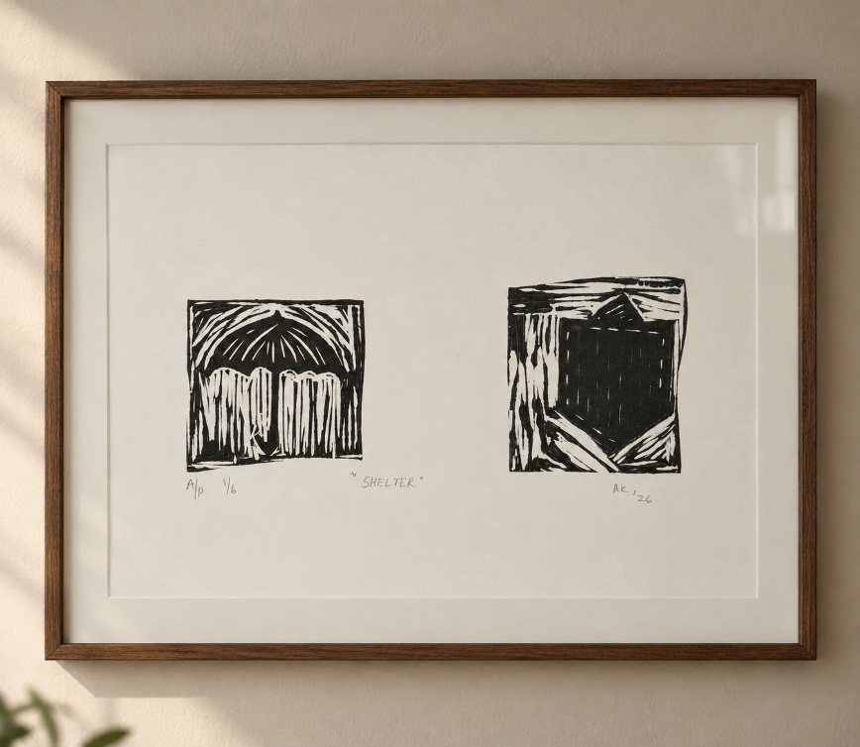
- Title: Shelter
- Theme: Father’s love
- Year: 2026
- Frame dimensions: 31.5 × 23 cm

Writeup
Shelter looks at fatherhood through the ordinary things fathers carry: a shirt pocket, always full, and an umbrella held over. Brought together in one print, these two forms speak of protection, provision and the quiet things that often go unnoticed. It is also an expression of gratitude for everything received while standing under someone's shelter. Each print is given a name before it leaves the studio, and the edition was made in six.

Instagram Captions
- I think of fathers through the ordinary things they carry.
A shirt pocket, always full.
An umbrella, held over someone else.
In Shelter, these two forms come together as a way of thinking about a father, about protection, provision, and the quiet things that often go unnoticed.
And perhaps, also, about gratitude.
For everything we receive while standing under someone's shelter.
- Every print gets a name before it leaves the studio.
- Made six of these, and honestly, signing the last one felt different.
- Okay, but does this belong on your wall or does this belong on your wall.

3. Ordinary Objects 1
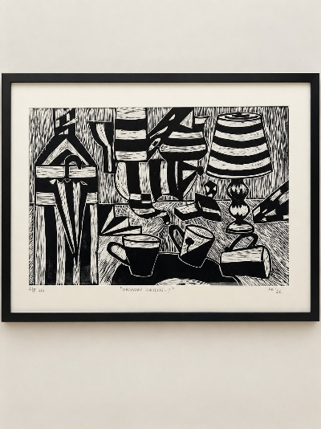
- Title: Ordinary Objects 1
- Theme: Micro spaces in macro environment
- Year: 2026
- Frame dimensions: 61 × 52 cm
- Print dimensions: 44.2 × 29.2 cm

Writeup
Ordinary Objects 1 is a linocut that grew out of the Covid period, when being homebound changed the way familiar surroundings were seen. Objects passed countless times began to occupy the small spaces of home, micro spaces within a macro environment. The piece observes a lamp and a few mismatched mugs closely, and honours the printmaking process itself, where the final image comes through adjustments and unsuccessful impressions rather than one perfect attempt.

Instagram Captions
- During Covid, being homebound changed the way I looked at my surroundings. Objects I had seen countless times began occupying the small spaces of home as micro spaces within a macro environment.
- Ordinary Objects I
A collection of familiar objects, observed closely during a time when home became the world around us.
- One of the things I like about printmaking is that the final image doesn't arrive in one perfect attempt.
There are adjustments, unsuccessful impressions and attempts that teach you what to change. And honestly, I don't want to hide that part of the process.
- Linocut is a relief printmaking technique.
The image is carved into a lino block, ink is applied to the raised surface, and the image is transferred onto paper.
- Proof that even a lamp and few mismatched mugs deserve their main character moment.

4. Ordinary Objects 3
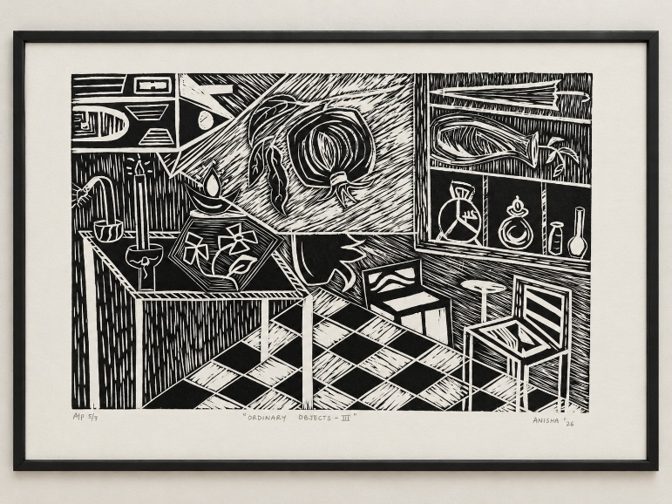
- Title: Ordinary Objects 3
- Theme: Micro spaces in macro environment
- Year: 2026
- Frame dimensions: 61 × 52 cm
- Print dimensions: 44.2 × 29.2 cm

Writeup
Ordinary Objects 3 continues the Micro Spaces in Macro Environment series, looking closely at the familiar spaces and objects that usually pass unnoticed: a candle, a flower, a few bottles on a shelf, a checkered floor. Documenting them reveals the ordinary things that make a home a home. Every texture, line of hatching and shade was carved by hand, one cut at a time, with no undo once the block is cut. The closer you look, the less ordinary it becomes.

Instagram Captions
- A continuation of my Micro Spaces in Macro Environment series, looking closely at the familiar spaces and objects that usually pass unnoticed.
Called it "Ordinary objects" because that's exactly what it is, a candle, a flower, a few bottles on a shelf, a checkered floor, nothing you'd stop and look at twice in real life.
That's the point.
When you sit down to document, you start noticing ordinary things which make home, home.
This one took me a while, mostly because there was just so much happening in one frame.
- Every line here was carved by hand, this is what it actually looks like.
- The closer I look, the less ordinary it becomes.
These close-ups are basically me showing off the process.
Carving this took patience, every texture, the hatching, shading, tiny details, all done one cut at a time, no shortcuts, no do-overs.
Printmaking teaches you to commit to a decision, because once it's carved, it's carved.
- Zooming into a piece you already saw, but this time it's about how it actually gets made. Every line here is carved by hand, there's no undo button once you cut into the block, so every mistake becomes part of the piece whether you like it or not.
What looks like a single confident stroke is usually the result of going over it slowly, checking the angle, testing the pressure, and hoping the linoleum doesn't chip where it's not supposed to.
It's slow work, but that's what makes it satisfying when it finally comes together.
- We tend to notice spaces when something changes.
This series began noticing what was already there. Some of these objects are just things I've grown up around.

5. Fish Painting
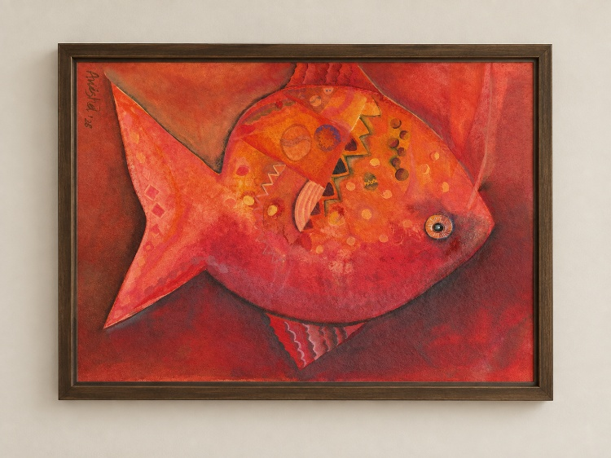
- Title: Fish Painting
- Theme: Contemporary art
- Year: 2026
- Dimensions: 80.5 × 60.5 cm

Writeup
Fish Painting treats contemporary art as a way of using different techniques to bring a subject to life, rather than following a single style. Traditional pattern-making meets bold, unapologetic colour across the body of the fish, with a tiny painting within the larger one waiting for those who zoom in. It is a celebration of Indian maximalism, patterns and colour, and of Indian contemporary art's ability to hold the old and the new at once.

Instagram Captions
- For me contemporary art isn't about following one style, it's about using different techniques to bring life to the subject.
This fish blends traditional pattern-making with bold, unapologetic colour, because Indian contemporary art has always known how to hold both the old and the new at once.
- This fish deserves more than a passing scroll, zoom in to see every pattern on its body.... to see a tiny painting within the larger one.
- Patterns and colors: Indian Maximalism

6. Forest Painting
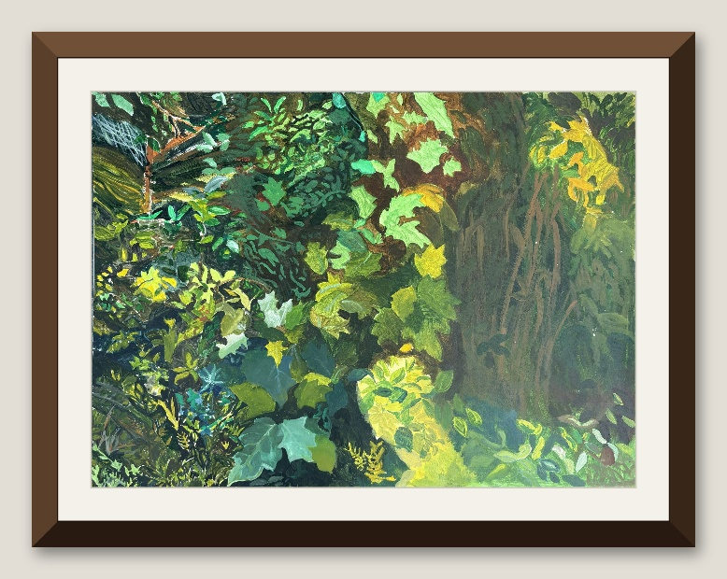
- Title: Forest Painting
- Theme: Contemporary art
- Year: 2021
- Dimensions: 79 × 58.6 cm

Writeup
Forest Painting is less about painting nature and more about painting light moving through it. Hours of work went into discovering that nature has its own unique shades and knows how to balance itself perfectly-imperfectly. Look closely and the greens split into entirely different shades, tones and textures.

Instagram Captions
- Spent hours painting this and can now confirm: Nature has its own unique shades. It knows how to balance itself perfectly-imperfectly.
- This piece is less about painting nature and more about painting light moving through it, the closer you look, the more the greens split into completely different shades, tones, and textures.

7. 108 Moon
[Framed picture: to be added]
- Title: 108 Moon
- Theme: Shiva element
- Year: 2026
- Frame dimensions: 52 × 61 cm
- Print dimensions: 30 × 29.5 cm

Writeup
108 Moon belongs to the Shiva series that began with the single Moon. Where that first print was a quiet single gesture, this piece builds on it through repetition, a recurring mark that works like a visual chant. Carved by hand, its small deviations are part of its character: an ordered system held together by the tension of the hand.

Instagram Captions
No captions yet.

